

**De La Salle University- Manila**

**Gokongwei College of Engineering**

Lab Activity Number : 4

Lab Activity Title : Thresholding

Date Performed : 10/15/2024

Date Submitted : 10/22/2024

Instructor : Jay Robert B. del Rosario, PhD

Name of Student : Collado, Andrei Vincent V.

Student ID : 12149616

Subject / Section : LBYCPF3/ Section

Remarks:

_______________________________________________________________

_______________________________________________________________

**Objectives:**

1. To Study the application of the difference thresholding techniques, including simple, adaptive-mean and adaptive-Gaussian, as well as automatically determined Otsu and Riddler-Calvard, for translation of gray-level images to binary images, and compare the efficacy of a technique about other techniques in various situations.
2. To analyze the effects of the type of threshold values and the methods used on the segmentation process of the images, particularly that of object-from-background contrast, to identify the most appropriate technique for thresholding images with various types of intensity distribution..

**Part I. Simulations**

**Example 1: simple_thresholding.py**

**Codes:**

| # USAGE  # python simple_thresholding.py --image ../images/coins.png  # Import the necessary packages  import numpy as np  import argparse  import cv2  # Construct the argument parser and parse the arguments  ap = argparse.ArgumentParser()  ap.add_argument("-i", "--image", required = True,      help = "Path to the image")  args = vars(ap.parse_args())  # Load the image, convert it to grayscale, and blur it slightly  image = cv2.imread(args["image"])  image = cv2.cvtColor(image, cv2.COLOR_BGR2GRAY)  blurred = cv2.GaussianBlur(image, (5, 5), 0)  cv2.imshow("Image", image)  # Let's apply basic thresholding. The first parameter is the  # image we want to threshold, the second value is is our threshold  # check. If a pixel value is greater than our threshold (in this  # case, 155), we it to be WHITE, otherwise it is BLACK.  (T, threshInv) = cv2.threshold(blurred, 155, 255, cv2.THRESH_BINARY_INV)  cv2.imshow("Threshold Binary Inverse", threshInv)  # Using a normal we can change the last argument in the function  # to make the coins black rather than white.  (T, thresh) = cv2.threshold(blurred, 155, 255, cv2.THRESH_BINARY)  cv2.imshow("Threshold Binary", thresh)  # Finally, let's use our threshold as a mask and visualize only  # the coins in the image  cv2.imshow("Coins", cv2.bitwise_and(image, image, mask = threshInv))  cv2.waitKey(0) |
| --- |

**Output Screenshot:**

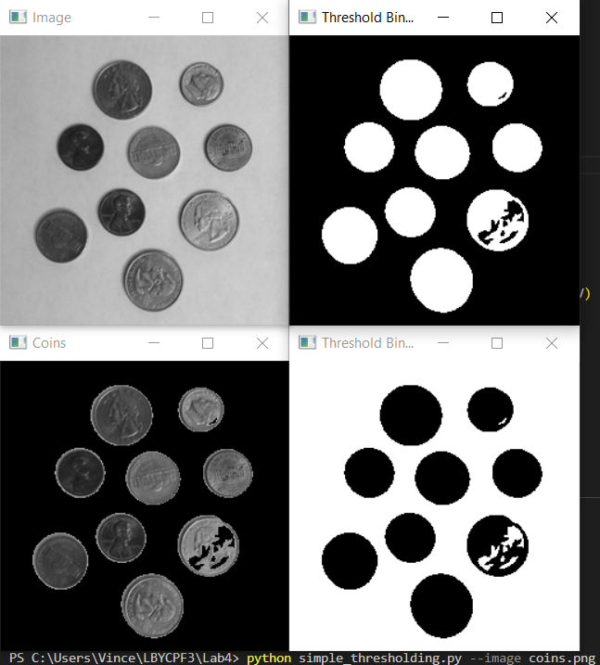

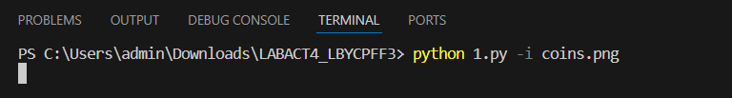

**Example 2: adaptive_thresholding.py**

**Codes:**

| # USAGE  # python adaptive_thresholding.py --image ../images/coins.png  # Import the necessary packages  import numpy as np  import argparse  import cv2  # Construct the argument parser and parse the arguments  ap = argparse.ArgumentParser()  ap.add_argument("-i", "--image", required = True,      help = "Path to the image")  args = vars(ap.parse_args())  # Load the image, convert it to grayscale, and blur it slightly  image = cv2.imread(args["image"])  image = cv2.cvtColor(image, cv2.COLOR_BGR2GRAY)  blurred = cv2.GaussianBlur(image, (5, 5), 0)  cv2.imshow("Image", image)  # In our previous example, we had to use manually specify a  # pixel value to globally threshold the image. In this example  # we are going to examine a neighborbood of pixels and adaptively  # apply thresholding to each neighborbood. In this example, we'll  # calculate the mean value of the neighborhood area of 11 pixels  # and threshold based on that value. Finally, our constant C is  # subtracted from the mean calculation (in this case 4)  thresh = cv2.adaptiveThreshold(blurred, 255,      cv2.ADAPTIVE_THRESH_MEAN_C, cv2.THRESH_BINARY_INV, 11, 4)  cv2.imshow("Mean Thresh", thresh)  # We can also apply Gaussian thresholding in the same manner  thresh = cv2.adaptiveThreshold(blurred, 255,      cv2.ADAPTIVE_THRESH_GAUSSIAN_C, cv2.THRESH_BINARY_INV, 15, 3)  cv2.imshow("Gaussian Thresh", thresh)  cv2.waitKey(0) |
| --- |

**Output Screenshot:**

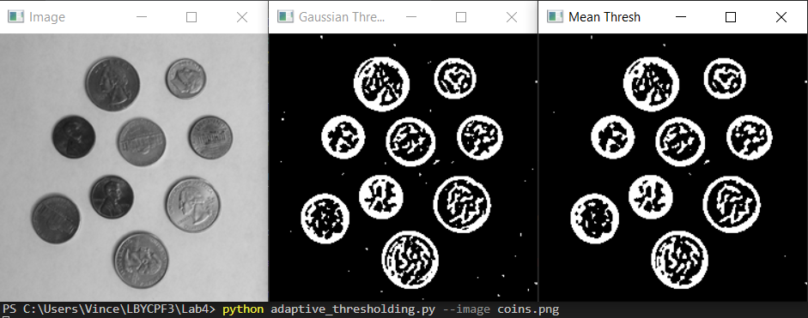



**Example 3: otsu_and_riddler.py**

**Codes:**

| # USAGE  # python otsu_and_riddler.py --image ../images/coins.png  # Import the necessary packages  from __future__ import print_function  import numpy as np  import argparse  import mahotas  import cv2  # Construct the argument parser and parse the arguments  ap = argparse.ArgumentParser()  ap.add_argument("-i", "--image", required = True,      help = "Path to the image")  args = vars(ap.parse_args())  # Load the image, convert it to grayscale, and blur it slightly  image = cv2.imread(args["image"])  image = cv2.cvtColor(image, cv2.COLOR_BGR2GRAY)  blurred = cv2.GaussianBlur(image, (5, 5), 0)  cv2.imshow("Image", image)  # OpenCV provides methods to use Otsu's thresholding, but I find  # the mahotas implementation is more 'Pythonic'. Otsu's method  # assumes that are two 'peaks' in the grayscale histogram. It finds  # these peaks, and then returns a value we should threshold on.  T = mahotas.thresholding.otsu(blurred)  print("Otsu's threshold: {}".format(T))  # Applying the threshold can be done using NumPy, where values  # smaller than the threshold are set to zero, and values above  # the threshold are set to 255 (white).  thresh = image.copy()  thresh[thresh > T] = 255  thresh[thresh < 255] = 0  thresh = cv2.bitwise_not(thresh)  cv2.imshow("Otsu", thresh)  # An alternative is to use the Riddler-Calvard method  T = mahotas.thresholding.rc(blurred)  print("Riddler-Calvard: {}".format(T))  thresh = image.copy()  thresh[thresh > T] = 255  thresh[thresh < 255] = 0  thresh = cv2.bitwise_not(thresh)  cv2.imshow("Riddler-Calvard", thresh)  cv2.waitKey(0) |
| --- |

**Output Screenshot:**

**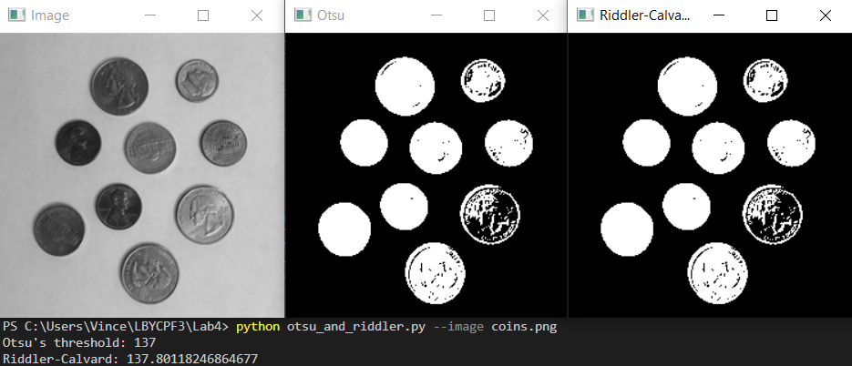  
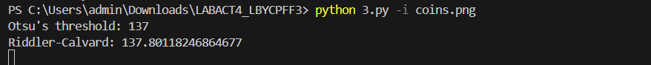**

**Output Screenshot:**

**Part II. Group Activity**

**Task 1:**

**Codes:**

| # Import the necessary packages from __future__ import print_function import cv2 import numpy as np import argparse  # Construct the argument parser and parse the arguments ap = argparse.ArgumentParser() ap.add_argument("-i", "--image", required=True, help="Path to the grayscale image") args = vars(ap.parse_args())  image = cv2.imread(args["image"]) cv2.imshow("Original", image)  # Load the image in grayscale mode image = cv2.imread(args["image"], cv2.IMREAD_GRAYSCALE)  # Loop through a set of threshold values to apply simple thresholding for T in range(50, 251, 50):     _, thresh = cv2.threshold(image, T, 255, cv2.THRESH_BINARY)      # Display the thresholded image     cv2.imshow(f"Threshold {T}", thresh)     cv2.waitKey(0)  cv2.destroyAllWindows() |
| --- |

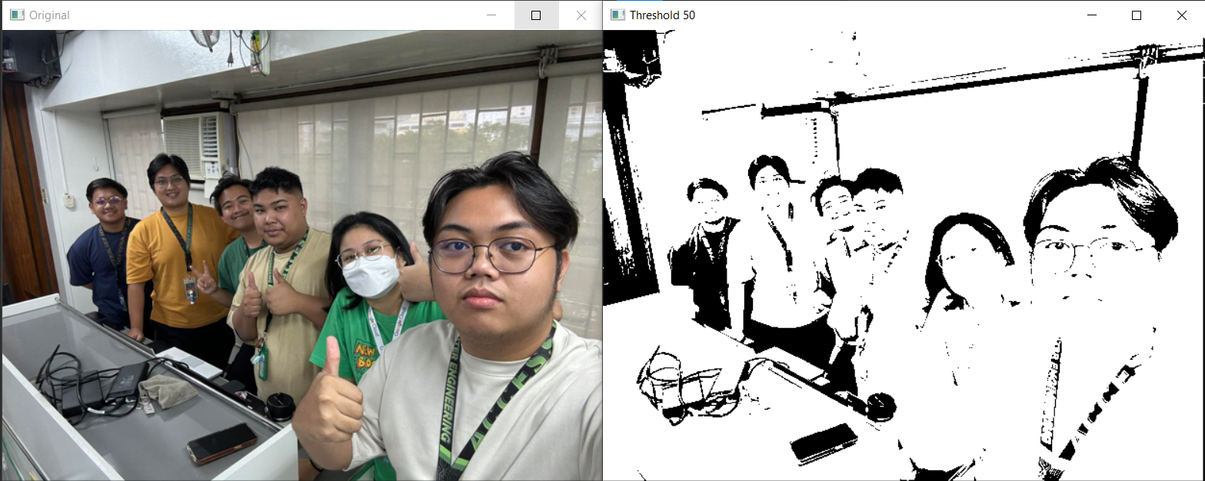

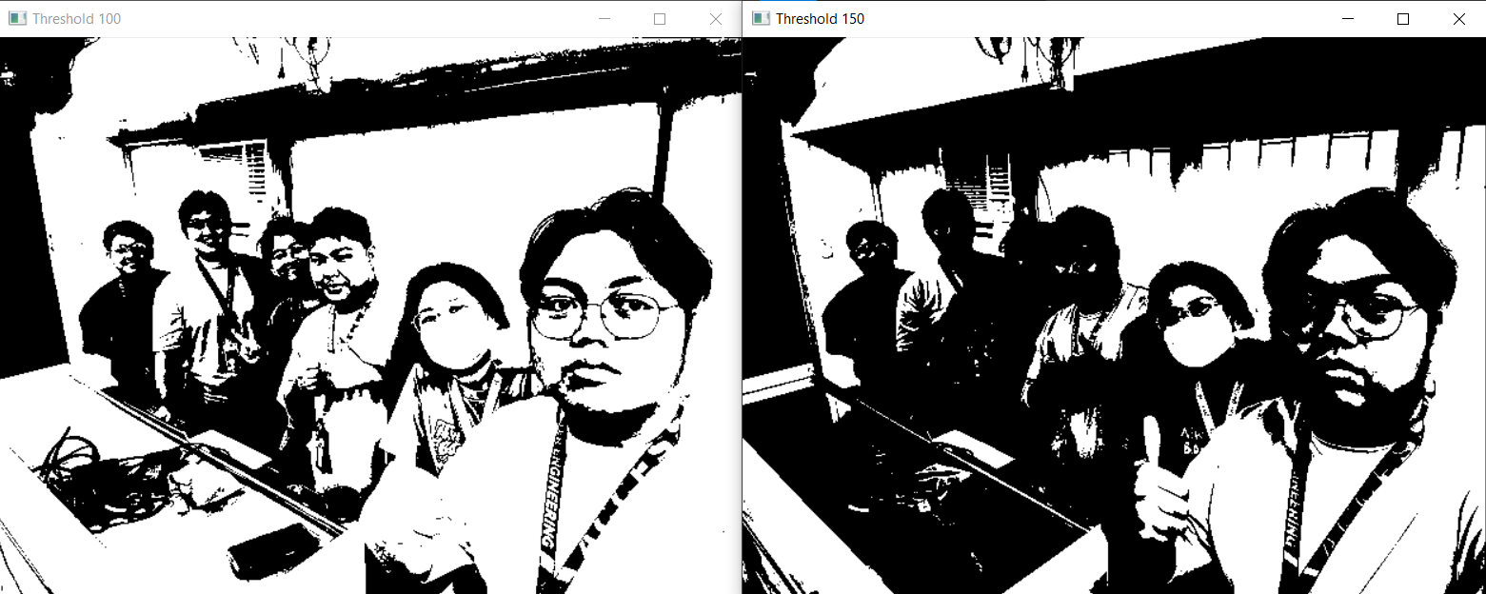

**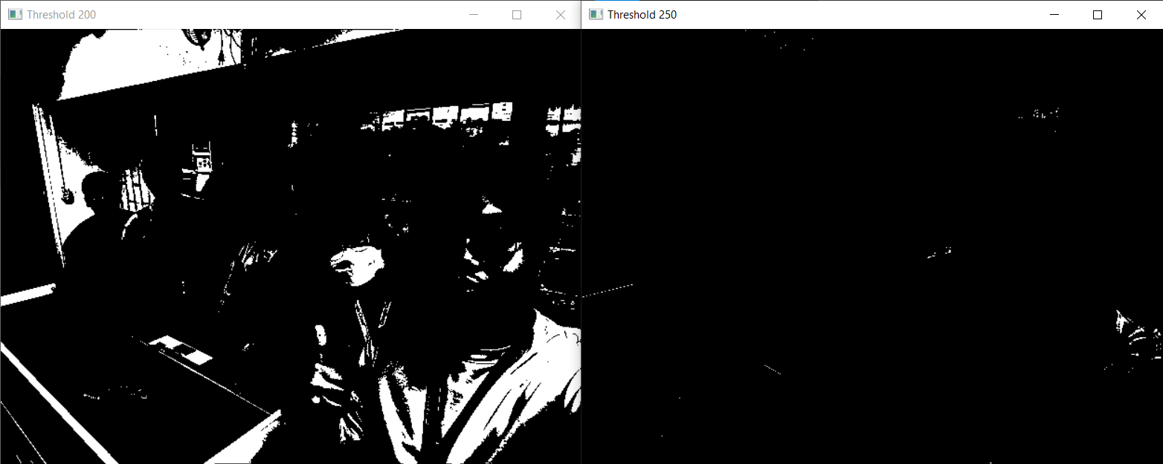  
**

**Discussion/Q and A:**

**Question:** How does altering the threshold value in simple thresholding impact the segmentation of objects in the image, and what challenges arise when selecting an optimal threshold for images with diverse intensity levels?

**Answer:** The level value in simple thresholding directly determines which pixels are viewed as foreground (objects) or background by adjusting the threshold. If the threshold is small, it will include many pixel intensities as foreground, so some detailed information will be included, but noise and over-segmentation results also exist. If the threshold is significant, more pixels are excluded, and parts of the object or the whole object may not be included resulting in under-segmentation. It becomes challenging to take the best threshold in images having varied intensities due to uneven illumination variations, differences in contrast, and even more complicated backgrounds, which makes it hard to properly isolate all objects existing across the image.

**Task 2:**

**Codes:**

| # Import the necessary packages  import cv2  import numpy as np  import argparse  import mahotas  # Construct the argument parser and parse the arguments  ap = argparse.ArgumentParser()  ap.add_argument("-i", "--image", required=True, help="Path to the grayscale image")  args = vars(ap.parse_args())  image = cv2.imread(args["image"])  cv2.imshow("Original", image)  # Load the image  image = cv2.imread(args["image"], cv2.IMREAD_GRAYSCALE)  # Apply simple thresholding  _, simple_thresh = cv2.threshold(image, 128, 255, cv2.THRESH_BINARY)  # Apply adaptive mean thresholding  adaptive_mean_thresh = cv2.adaptiveThreshold(image, 255, cv2.ADAPTIVE_THRESH_MEAN_C, cv2.THRESH_BINARY, 11, 2)  # Apply adaptive Gaussian thresholding  adaptive_gauss_thresh = cv2.adaptiveThreshold(image, 255, cv2.ADAPTIVE_THRESH_GAUSSIAN_C, cv2.THRESH_BINARY, 11, 2)  # Apply Otsu's thresholding  _, otsu_thresh = cv2.threshold(image, 0, 255, cv2.THRESH_BINARY + cv2.THRESH_OTSU)  # Apply Riddler-Calvard thresholding using mahotas  T_riddler_calvard = mahotas.thresholding.rc(image)  riddler_thresh = image.copy()  riddler_thresh[riddler_thresh > T_riddler_calvard] = 255  riddler_thresh[riddler_thresh <= T_riddler_calvard] = 0  riddler_thresh = riddler_thresh.astype(np.uint8)  # Display the results  cv2.imshow("Simple Threshold", simple_thresh)  cv2.imshow("Adaptive Mean Threshold", adaptive_mean_thresh)  cv2.imshow("Adaptive Gaussian Threshold", adaptive_gauss_thresh)  cv2.imshow("Otsu's Threshold", otsu_thresh)  cv2.imshow("Riddler-Calvard Threshold", riddler_thresh)  cv2.waitKey(0)  cv2.destroyAllWindows() |
| --- |

**Output Screenshot:**

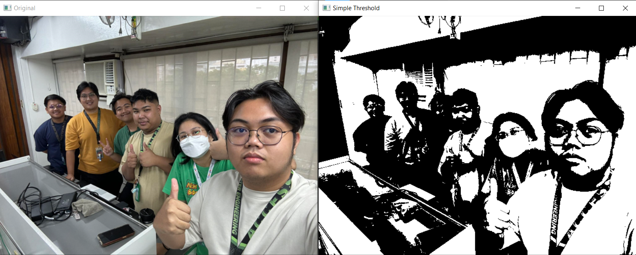

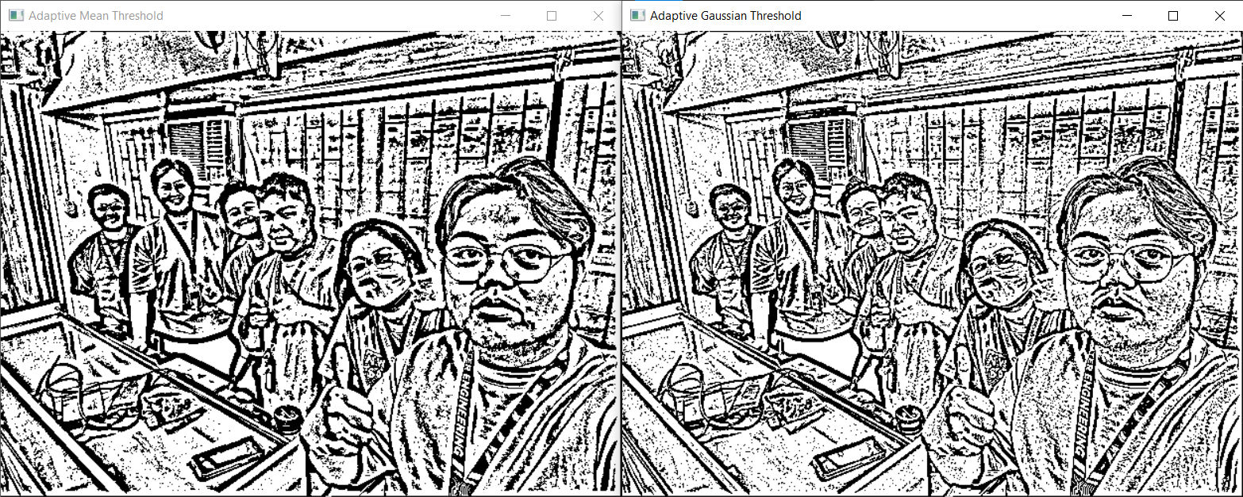

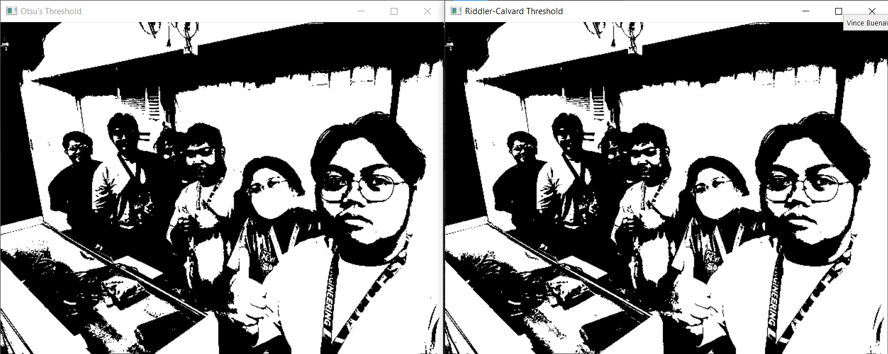

**Discussion/Q and A:**

**Question:** How do the results of different thresholding methods compare in terms of accurately segmenting the objects from the background, and which method performs best for images with uneven lighting or complex backgrounds?

**Answer:** Segmentation between objects and background depends highly on the type of thresholding technique applied. While simple thresholding uses a global threshold, which in many cases may ignore the various illuminations that have occurred in the image, inappropriate segmentation occurs when illumination is not uniform or very complex with background. Some of these techniques fall under adaptive thresholding, such as adaptive mean and adaptive Gaussian thresholding. These techniques calculate the threshold for smaller parts of an image, hence it adapts according to local variations in intensity, which makes it perfect for uneven lighting and intricate backgrounds. The better amongst these is adaptive Gaussian, as it computes the weighted sum of neighborhood pixels, hence reducing noise and giving much smoother transitions while better preserving edge details. Thresholding by Otsu automatically determines an optimal global threshold that maximizes variance between foreground and background. It is appropriate for bimodal histograms but fails in complex backgrounds. Riddler-Calvard thresholding is similar, but in images having large variations in intensities, the outcomes would be less precise. So, for those images which contain uneven lighting or have complicated backgrounds, adaptive thresholding techniques, especially adaptive Gaussian thresholding, are likely to produce the best performance in terms of segmentation accuracy.

**Task 3:**

**Codes:**

| # Import the necessary packages  import cv2  import mahotas  import argparse  import numpy as np  # Construct the argument parser and parse the arguments  ap = argparse.ArgumentParser()  ap.add_argument("-i", "--image", required=True, help="Path to the grayscale image")  args = vars(ap.parse_args())  image = cv2.imread(args["image"])  cv2.imshow("Original", image)  # Load the grayscale image  image = cv2.imread(args["image"], cv2.IMREAD_GRAYSCALE)  cv2.imshow("Grayscaled Image", image)  # Apply Otsu's method  _, otsu_thresh_doc = cv2.threshold(image, 0, 255, cv2.THRESH_BINARY + cv2.THRESH_OTSU)  # Apply Riddler-Calvard method  T_riddler_doc = mahotas.thresholding.rc(image)  riddler_thresh_doc = image.copy()  riddler_thresh_doc[riddler_thresh_doc > T_riddler_doc] = 255  riddler_thresh_doc[riddler_thresh_doc <= T_riddler_doc] = 0  riddler_thresh_doc = riddler_thresh_doc.astype(np.uint8)  # Display the results for document binarization  cv2.imshow("Otsu Threshold on Document", otsu_thresh_doc)  cv2.imshow("Riddler-Calvard Threshold on Document", riddler_thresh_doc)  cv2.waitKey(0)  cv2.destroyAllWindows() |
| --- |

**Output Screenshot:**

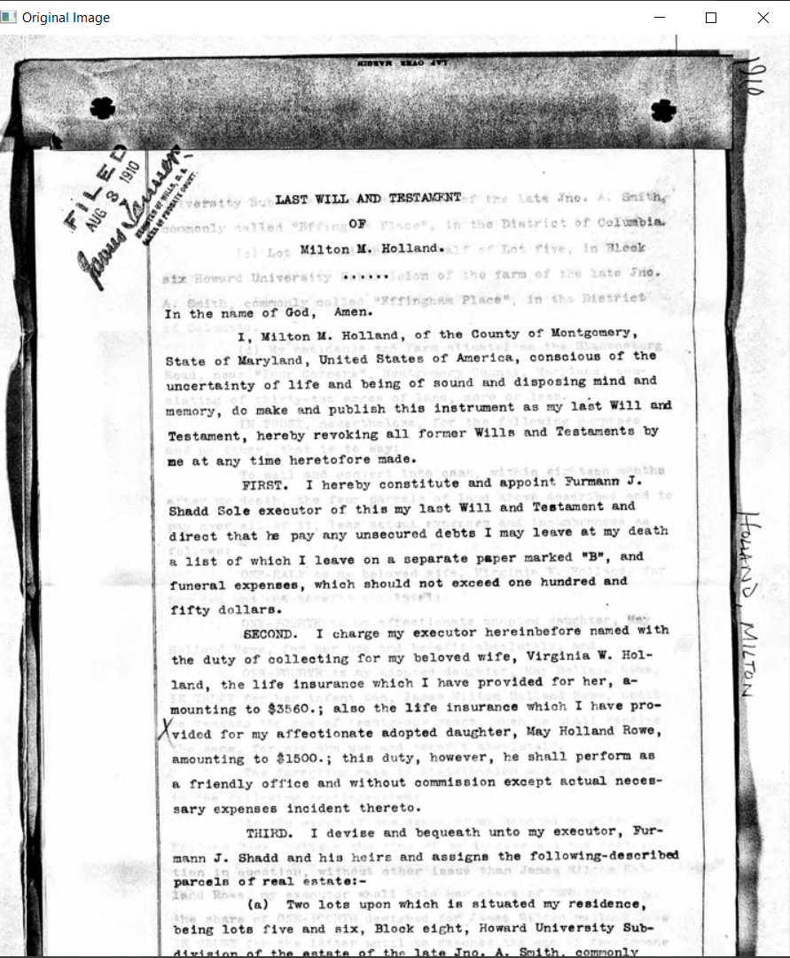 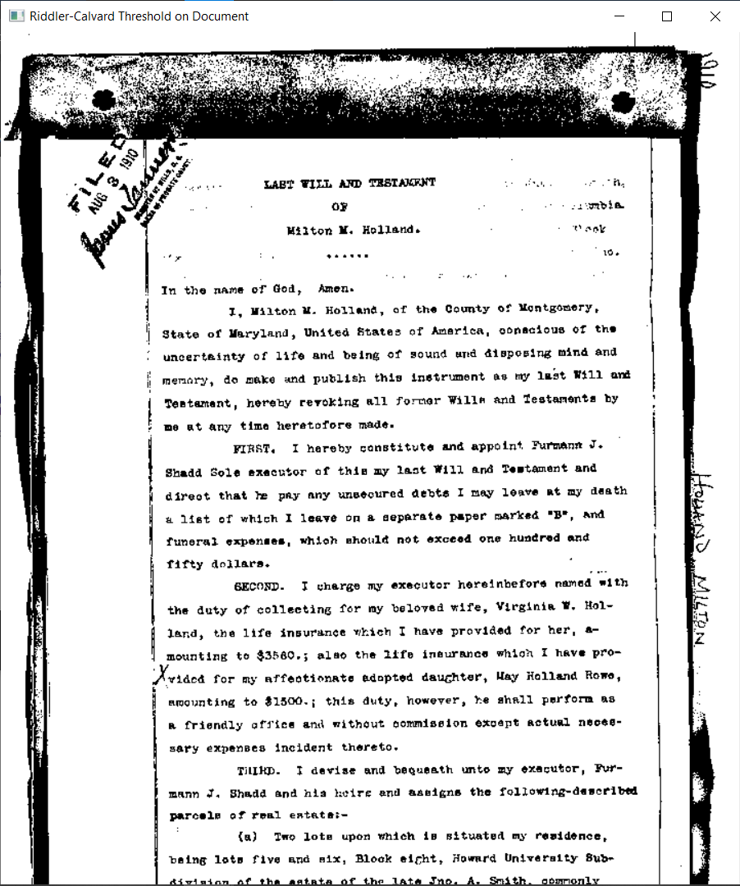

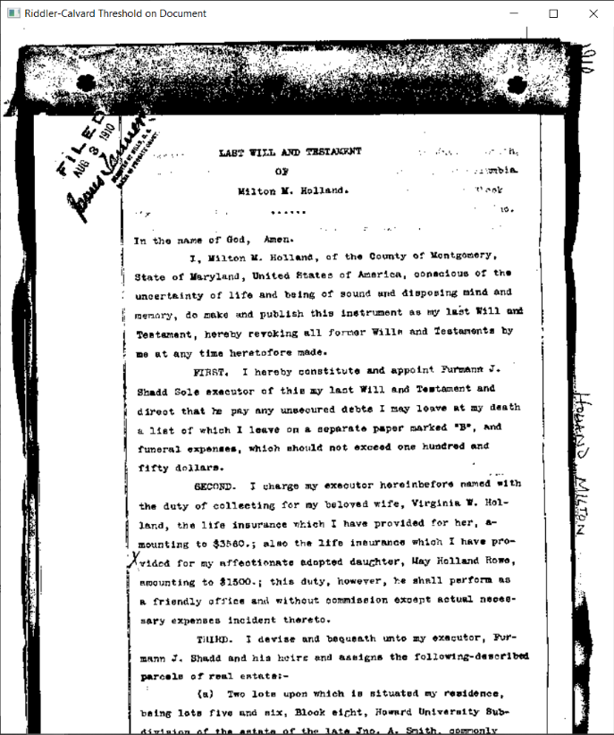

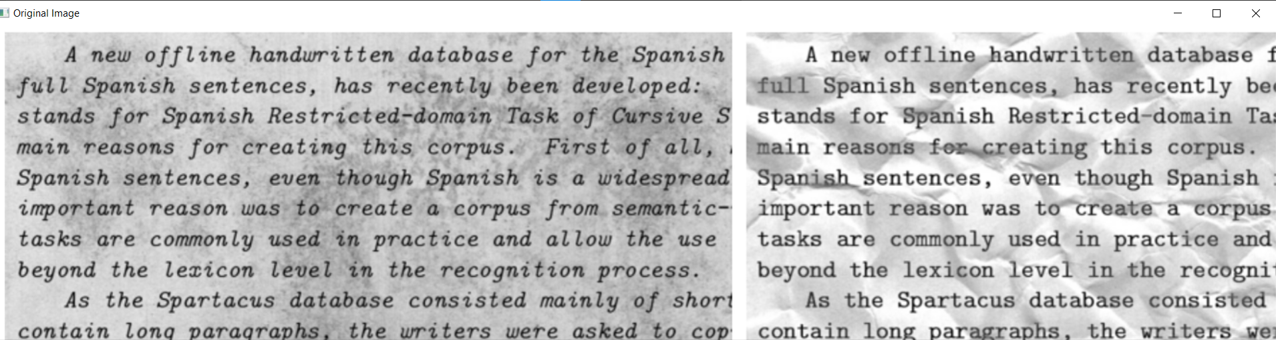

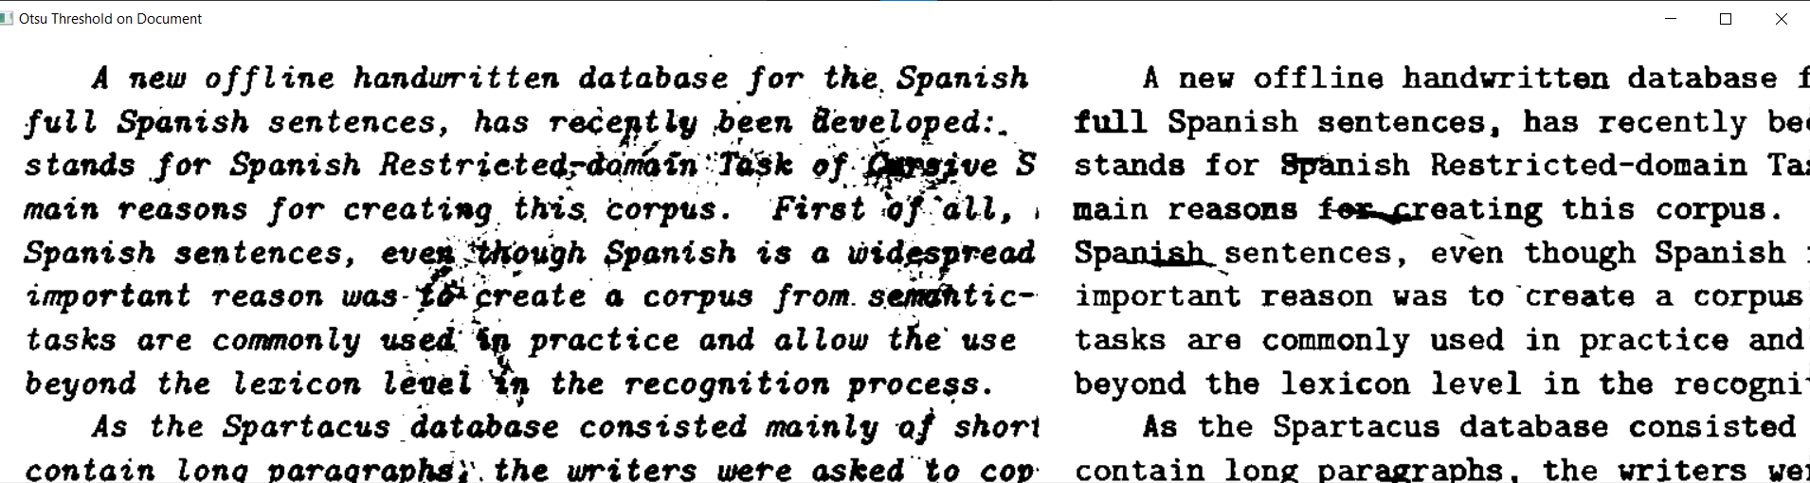

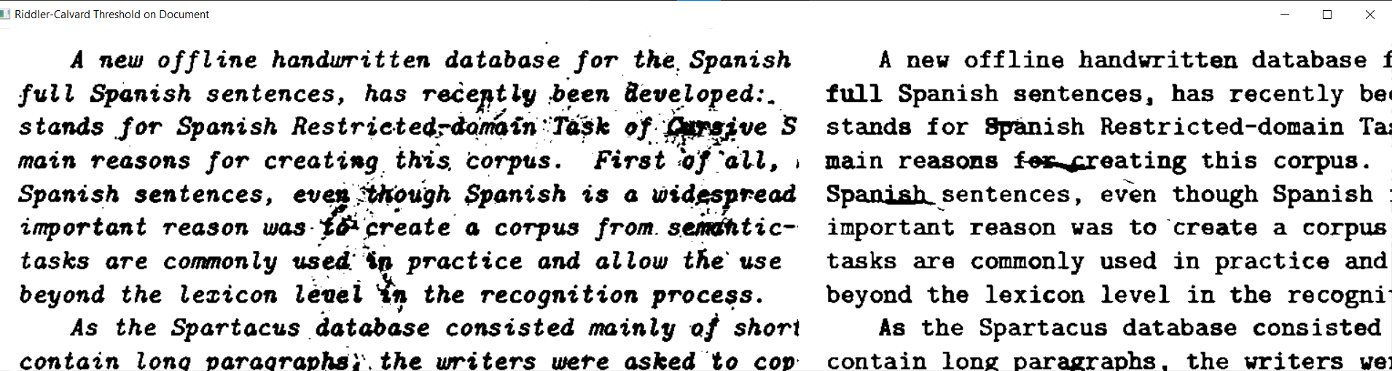

**Discussion/Q and A:**

**Question:** Compare and contrast the thresholding methods: Simple, Adaptive, Otsu, and Riddler-Calvard.

**Answer:**

**Task 4:**

**Codes:**

| # Import the necessary packages  import cv2  import mahotas  import argparse  import numpy as np  # Construct the argument parser and parse the arguments  ap = argparse.ArgumentParser()  ap.add_argument("-i", "--image", required=True, help="Path to the grayscale image")  args = vars(ap.parse_args())  image = cv2.imread(args["image"])  cv2.imshow("Original", image)  # Load the MRI image  mri_image = cv2.imread(args["image"], cv2.IMREAD_GRAYSCALE)  cv2.imshow("Graryscaled Image", mri_image)  # Apply Otsu’s and Riddler-Calvard thresholding  _, otsu_thresh_mri = cv2.threshold(mri_image, 0, 255, cv2.THRESH_BINARY + cv2.THRESH_OTSU)  T_riddler_mri = mahotas.thresholding.rc(mri_image)  riddler_thresh_mri = mri_image.copy()  riddler_thresh_mri[riddler_thresh_mri > T_riddler_mri] = 255  riddler_thresh_mri[riddler_thresh_mri <= T_riddler_mri] = 0  riddler_thresh_mri = riddler_thresh_mri.astype(np.uint8)  # Display MRI segmentation results  cv2.imshow("Otsu Threshold on MRI", otsu_thresh_mri)  cv2.imshow("Riddler-Calvard Threshold on MRI", riddler_thresh_mri)  cv2.waitKey(0)  cv2.destroyAllWindows() |
| --- |

**Output Screenshot:**

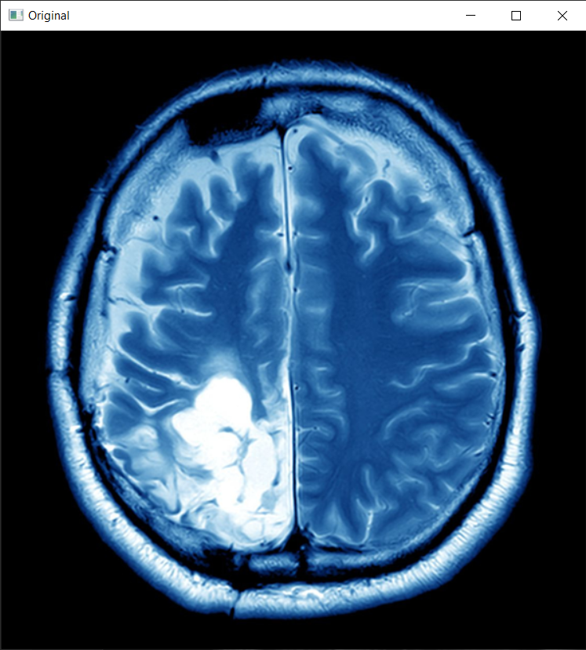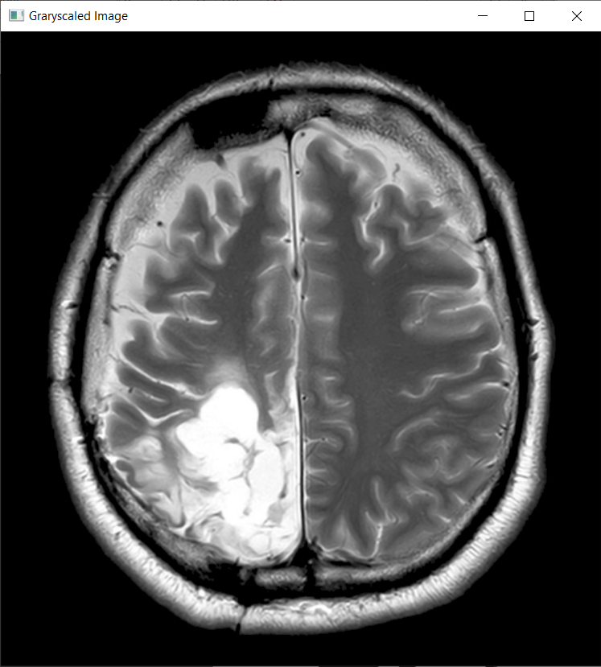 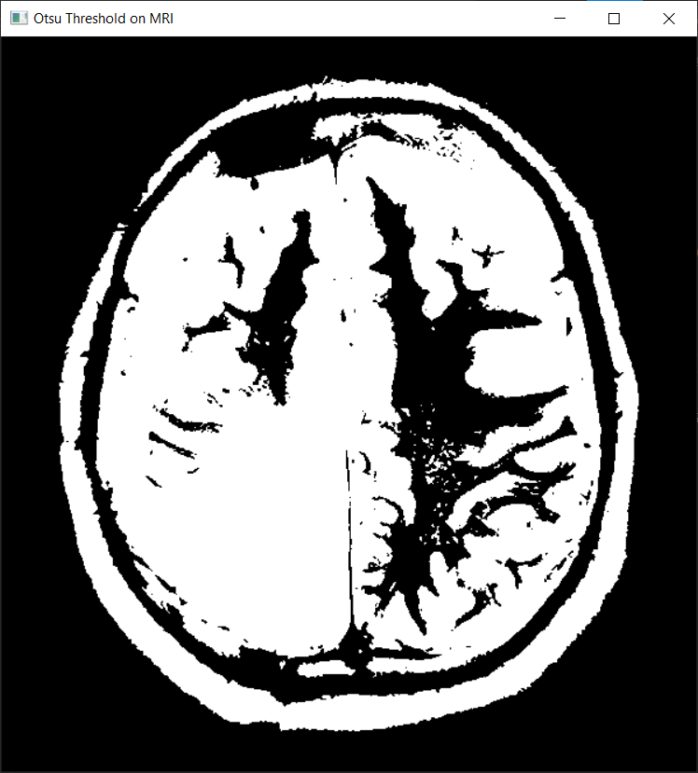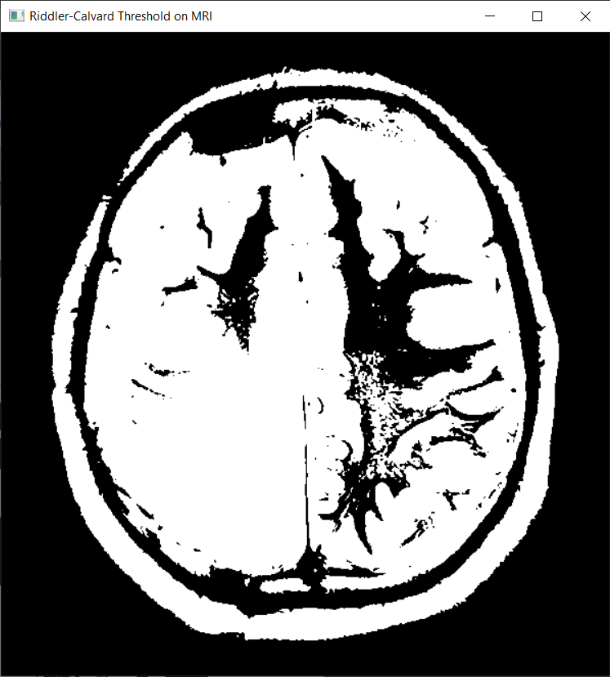

**Part III. Individual Activity**

**Codes**

| **import cv2**  **import numpy as np**  **import mahotas**  **import matplotlib.pyplot as plt**  **# List of image paths**  **image_paths = ['object.jpg', 'letterhead.jpg', 'noisy.jpg']**  **# Function to display images side by side**  **def show_images(titles, images, cmap='gray'):**  **n = len(images)**  **plt.figure(figsize=(20, 8))**  **for i in range(n):**  **plt.subplot(1, n, i + 1)**  **plt.imshow(images[i], cmap=cmap)**  **plt.title(titles[i])**  **plt.axis('off')**  **plt.show()**  **for img_path in image_paths:**  **# Load the image in grayscale**  **image = cv2.imread(img_path, cv2.IMREAD_GRAYSCALE)**  **original = image.copy()**  **# Check if image is loaded**  **if image is None:**  **print(f"Error: Could not load image {img_path}")**  **continue**  **# Apply Simple Thresholding with a manual threshold**  **_, simple_thresh = cv2.threshold(image, 128, 255, cv2.THRESH_BINARY)**  **# Apply Adaptive Mean Thresholding**  **adaptive_mean_thresh = cv2.adaptiveThreshold(**  **image, 255, cv2.ADAPTIVE_THRESH_MEAN_C, cv2.THRESH_BINARY, 11, 2)**  **# Apply Adaptive Gaussian Thresholding**  **adaptive_gauss_thresh = cv2.adaptiveThreshold(**  **image, 255, cv2.ADAPTIVE_THRESH_GAUSSIAN_C, cv2.THRESH_BINARY, 11, 2)**  **# Apply Otsu's Thresholding**  **# Preprocess with Gaussian blur for better results**  **blurred = cv2.GaussianBlur(image, (5, 5), 0)**  **_, otsu_thresh = cv2.threshold(**  **blurred, 0, 255, cv2.THRESH_BINARY + cv2.THRESH_OTSU)**  **# Apply Riddler-Calvard Thresholding using mahotas**  **T_riddler_calvard = mahotas.thresholding.rc(image)**  **riddler_thresh = image.copy()**  **riddler_thresh[riddler_thresh > T_riddler_calvard] = 255**  **riddler_thresh[riddler_thresh <= T_riddler_calvard] = 0**  **riddler_thresh = riddler_thresh.astype(np.uint8)**  **# Display the results**  **titles = ['Original', 'Simple Threshold', 'Adaptive Mean',**  **'Adaptive Gaussian', "Otsu's Method", 'Riddler-Calvard']**  **images = [original, simple_thresh, adaptive_mean_thresh,**  **adaptive_gauss_thresh, otsu_thresh, riddler_thresh]**  **show_images(titles, images)** |
| --- |

**Output Screenshot**

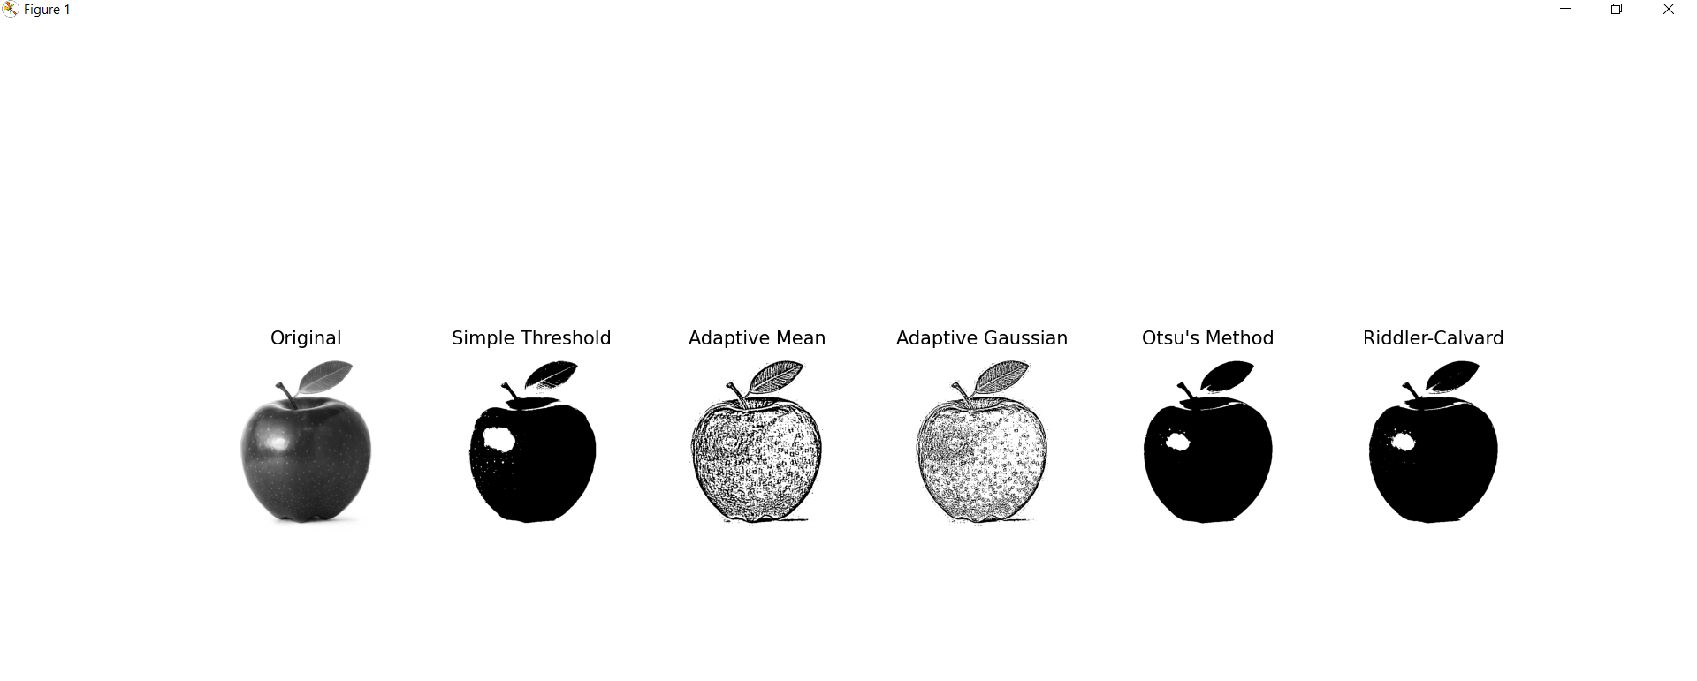

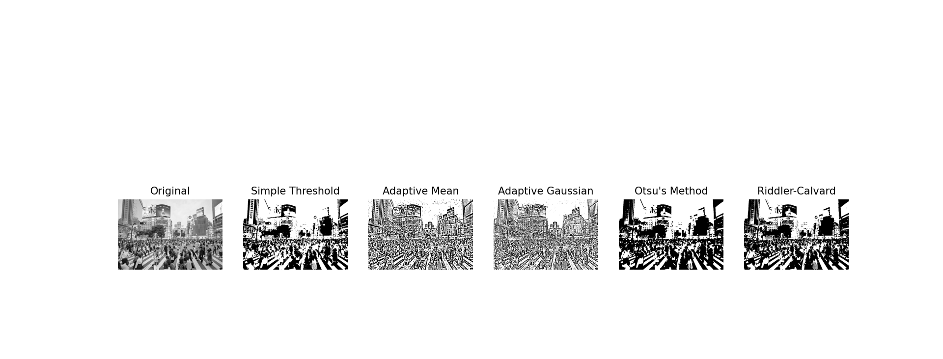

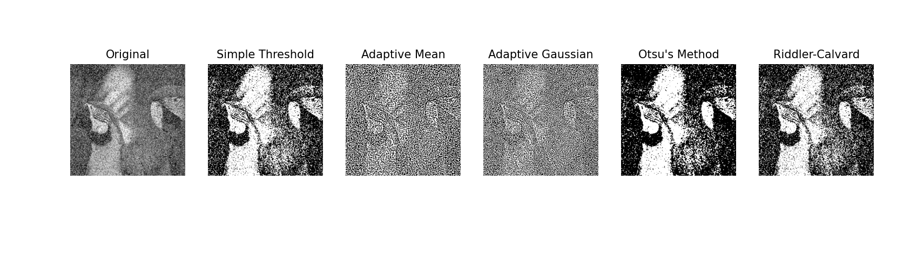



**Discussion/Q and A:**

Which thresholding method provides the most reliable and accurate segmentation across a variety of image conditions, and how do preprocessing steps like blurring influence the effectiveness of each method?

**Answer:**Among these thresholding methods, namely, simple thresholding, adaptive mean, adaptive Gaussian, Otsu's, and Riddler-Calvard thresholding, the adaptive Gaussian thresholding method provides maximum output in terms of reliability and accuracy of segmentation under numerous conditions about images. Adaptive Gaussian thresholding computes its thresholds for small areas based on a weighted sum computed from all pixels in the neighborhood of an area under consideration to adapt to local illumination and contrast variations. This makes it very effective for images with uneven lighting, complex backgrounds, and different intensities of objects. It also preserves the edge details and the noise impact is lower when compared to global thresholding methods.

The preprocessing level, such as blurring, is significant in each technique's efficiency. Preprocessing with blurring techniques, such as Gaussian or median blur, before applying thresholding can remove noise and smooth intensity variation, which is helpful for Otsu's thresholding methods using global techniques. However, blurring offers a crisp intensity contrast between the foreground and background, thus potentially giving better results for threshold estimation. However, excessive blurring would remove important details and intensity variations that adaptive methods rely upon for optimal performance. Therefore, while blurring enhances the performance of some thresholding algorithms by eliminating noise, it must be used appropriately so that segmentation quality is not degraded, especially in adaptive thresholding, which relies on the features learned from local images.

**Conclusion:**In this lab activity, we applied some thresholding techniques that convert greyscale images to binary images to correctly divide images, which include simple thresholding, adaptive mean thresholding, adaptive Gaussian thresholding, Otsu's method, and Riddler-Calvard thresholding. In the implementation, we run different simulations realizing how each method performs in various image conditions, such as simple well-lit objects, complex backgrounds with uneven lighting, and high-noise images.

This shows that the choice of thresholding affects the accuracy and reliability of image segmentation. Simple thresholding works satisfactorily for uniform illumination and contrast, but its results degenerate to those images whose background is complex or whose illumination varies across the images. This is problematic because choosing the appropriate global threshold is a difficult in such scenarios where intensity varies greatly across the image. Among the thresholding techniques, adaptive Gaussian thresholding was among the most reliable and accurate ones, especially when tested with several image conditions. Weighted sums of neighborhood pixels as local thresholds make adaptive Gaussian thresholding more vigorous in handling uneven illumination, thus preserving sharp edge details and its adaptability to local variations in illumination and contrast, placing the method in a position to predict global methods would fail. Otsu's method and Riddler-Calvard thresholding, which automatically determines optimal global thresholds, did pretty well on bimodal histograms but not so well in images with strong intensity or noise variations. These are noisy and variance-based methods and thus are sensitive to illumination, hence prone to incorrect segmentation.

The adaptive Gaussian thresholding proved the most effective and robust under all other conditions. This approach thrives well respecting uneven illumination, complicated backgrounds, and inhomogeneous intensities of objects while keeping the essential information from the image. Although blurring and other preprocessing techniques help enhance the outcome of the segmentation process, these methods should be applied without over-removing the noise since this may degrade the essential features of the image. Success in image segmentation is highly dependent on the proper thresholding technique chosen in conjunction with appropriate preprocessing based on the inherent characteristics of the image.

**Part IV. Peer Evaluation Form**

Review the rubric at the end of this rating sheet. Write the name of each of your group members in a separate column. For each person, indicate the extent to which you agree with the statement on the left, using the percentage points in the rubric (0-100%).

| Evaluation Criteria | Group member: Collado, Andrei Vincent  Name: Buenaventura, Vince Craig S. | Group member: Dela Cruz, John Carlo Theo S.  Name: Buenaventura, Vince Craig S. | Group member: Agno, Joackim  Name: Buenaventura, Vince Craig S. | Group member: De Villa, Bianca Mikaella B.  Name: Buenaventura, Vince Craig S. | Group member: Sta. Monica, Geoffrey  Name: Buenaventura, Vince Craig S. |
| --- | --- | --- | --- | --- | --- |
| Contribute in a valuable way towards attainment of the objectives | 100 | 100 | 100 | 100 | 100 |
| Ability to function on multidisciplinary teams | 100 | 100 | 100 | 100 | 100 |
| Problem-solving | 100 | 100 | 100 | 100 | 100 |
| Attitude | 100 | 100 | 100 | 100 | 100 |
| Focus on the task | 100 | 100 | 100 | 100 | 100 |
| Overall Performance Rating | 100 | 100 | 100 | 100 | 100 |
| AVERAGE | 100 | 100 | 100 | 100 | 100 |

|  |  | |  | |  |  |  |  |
| --- | --- | --- | --- | --- | --- | --- | --- | --- |
| Criteria | | EXEMPLARY  (94-100) | | SATISFACTORY  (83-93) | | DEVELOPING  (70-82) | BEGINNING  (BELOW 70) |
| Contribute in a valuable way towards attainment of the objectives | | Team member is fully engaged with effective exchange of ideas towards the achievement of the objectives. | | Team member is engaged most of the time. The exchange of ideas towards the achievement of the objectives is effective most of the time. | | Team member is engaged but can be distracted. Ideas towards the achievement of the objectives are exchanged with encouragement. | Team member is only engaged with encouragement or not all team members are engaged. Ideas towards the achievement of the objectives are not exchanged effectively. |
| Ability to function on multidisciplinary teams | | Members working in a multidisciplinary team share respect for each other. All team members of the group feel free to ask questions and contribute. Conflicts are resolved with open dialogue and compromise. | | There is a general atmosphere of respect for members working in a multidisciplinary team. The majority of team members feel free to ask questions and contribute. Team members are generally able to resolve conflicts through open discussion. | | There is a general atmosphere of respect for Members working in a multidisciplinary team, but some team members of the group do not feel free to ask questions and contribute. Team members are generally able to resolve conflicts through open discussion with outside assistance. | Members working in a multidisciplinary team atmosphere is competitive and/or individualistic. Conflicts that arise are not dealt with or cannot be resolved and/or there are no effective group interactions. |
| Problem Solving | | Actively looks for and suggests solutions to problems. | | Refines solutions suggested by others. | | Does not suggest or refine solutions but is willing to try out solutions suggested by others. | Does not try to solve problems or help others solve problems.  Let’s others do the work. |
| Attitude | | Is never publicly critical of the project or the work of others. Always has a positive attitude about the task(s). | | Is rarely publicly critical of the project or the work of others. Often has a positive attitude about the task(s). | | Is occasionally publicly critical of the project or the work of other members of the group. Usually has a positive attitude about the task(s). | Is often publicly critical of the project or the work of other members of the group. Is often negative about the task(s). |
| Focus on the task | | Consistently stays focused on the task and what needs to be done. Very self-directed. | | Focuses on the task and what needs to be done most of the time. Other group members can count on this person. | | Focuses on the task and what needs to be done some of the time. Other group members must sometimes nag, prod, and remind to keep this person on task. | Rarely focuses on the task and what needs to be done. Let’s others do the work. |
| Overall Performance Rating | | Performance consistently  exceeds all group  requirements. | | Performance meets all group  requirements consistently and  sometimes exceeds  requirements. | | Performance meets all group  requirements. | Performance fails to meet  some group requirements. |